Terraform-04

To restrict the particular version of provider

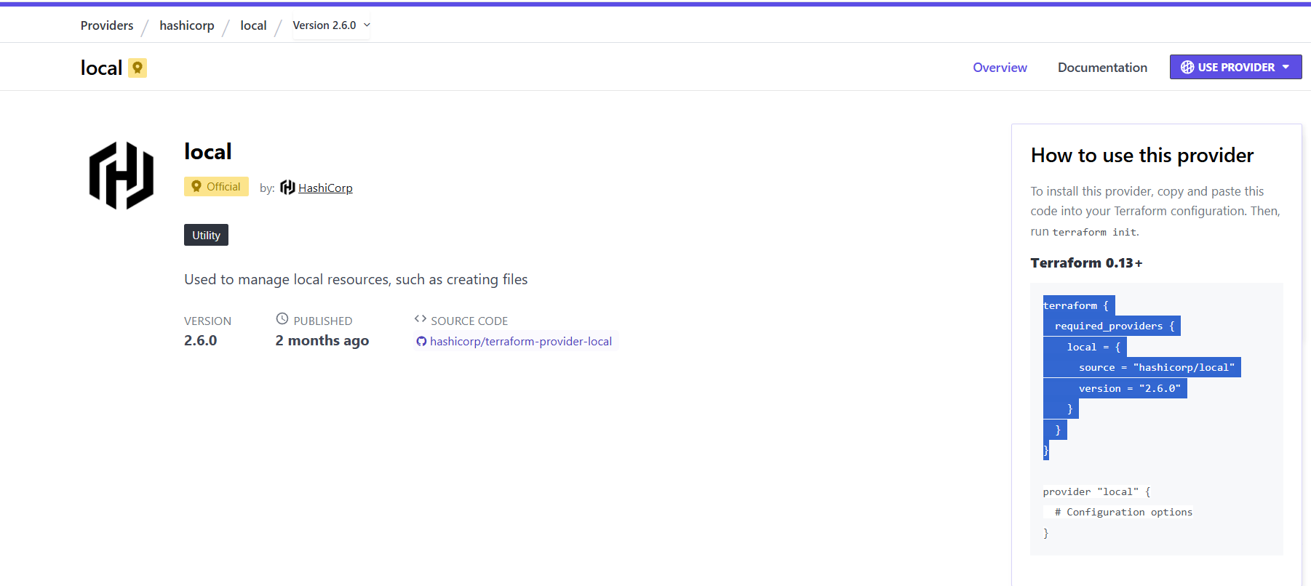
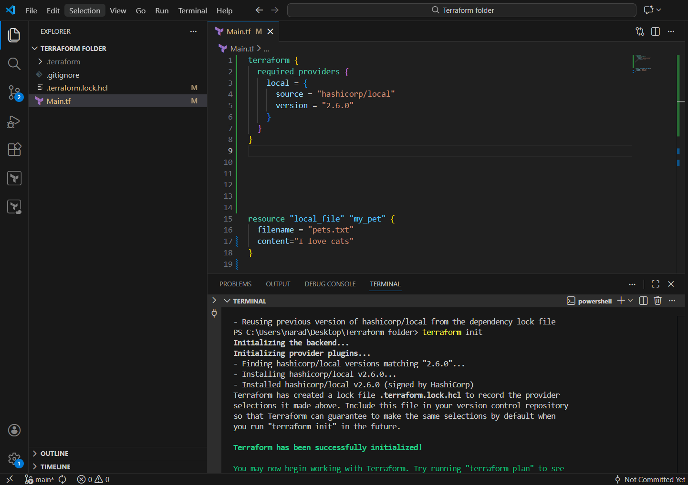

Version = “2.6.0” - To download the exact version.
Version = “!=2.6.0” – Will not use the mentioned version.
Version = “< 2.6.0” -Less than the mentioned version.
Version = “>2.6.0” – Greater than the mentioned version.
Version = “~>2.6.0” – Specific version or higher version.

Here previous version was “2.6.0” now it is “2.6.1”.
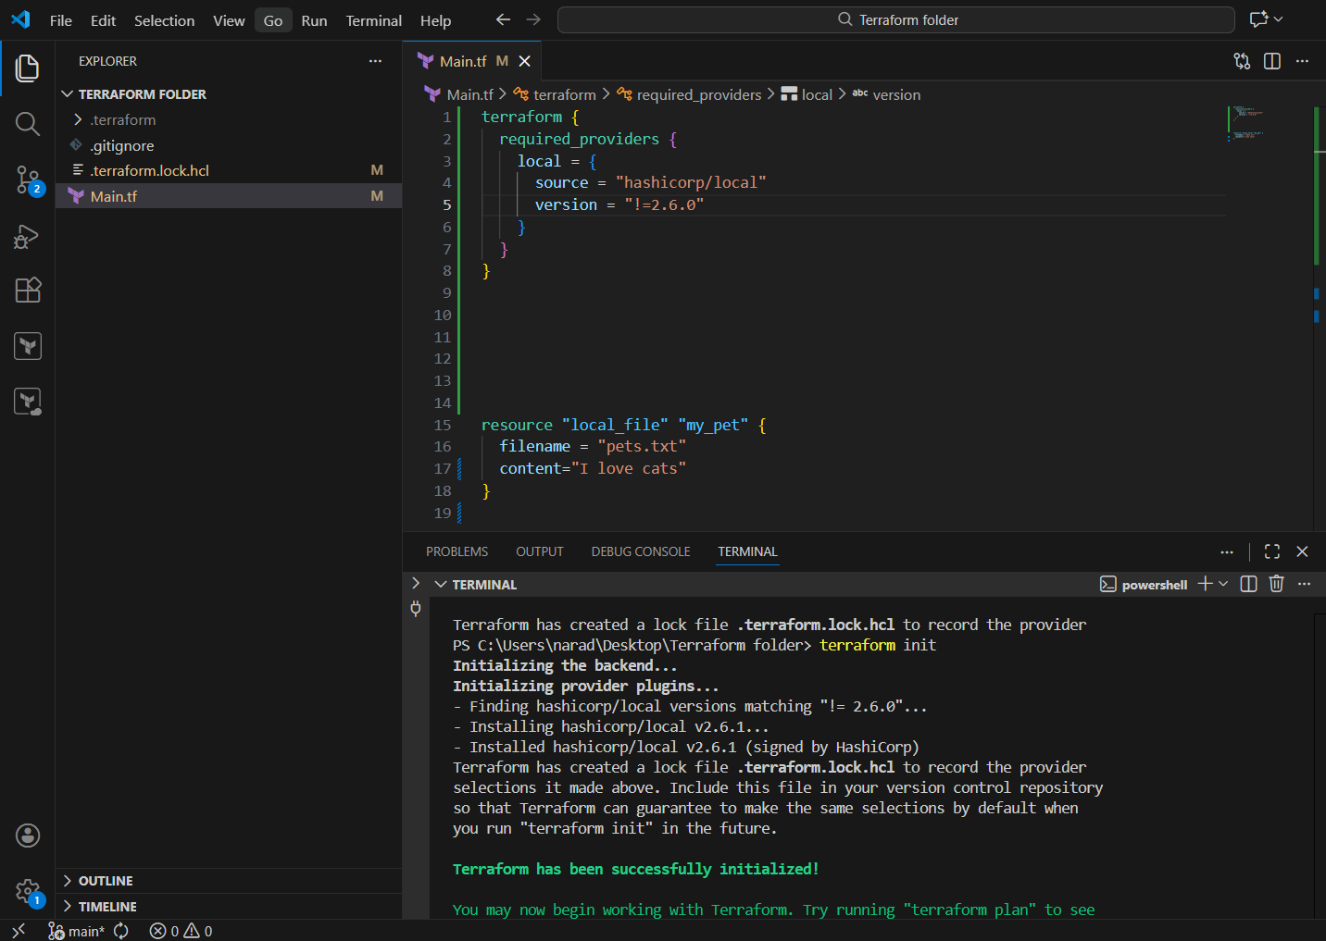

Data sources:

What are Data Sources in Terraform?

📌 Simple definition
Data sources in Terraform are used to READ existing infrastructure information, not to create anything.
They fetch data from:
- Existing cloud resources
- Existing files
- Existing configurations

Previously manually entered the content inside the file dogs.txt that “ I love dogs”.
Now through the data blocks we can read the content of the file Dogs.txt by transferring the content to pets.txt.
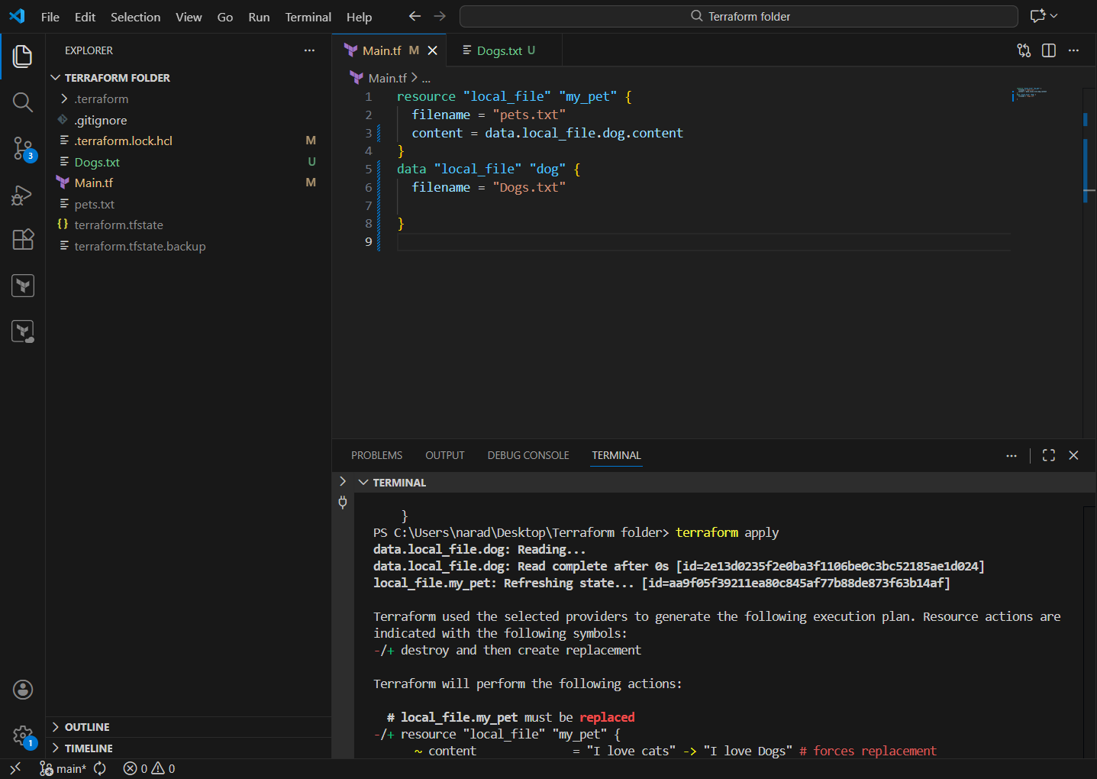
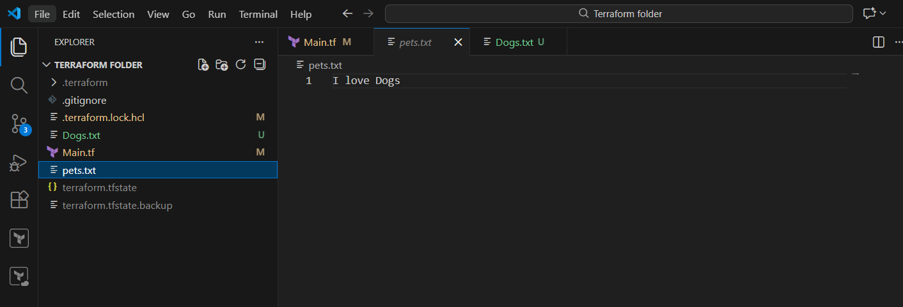

Creating an IAM user using terraform script.
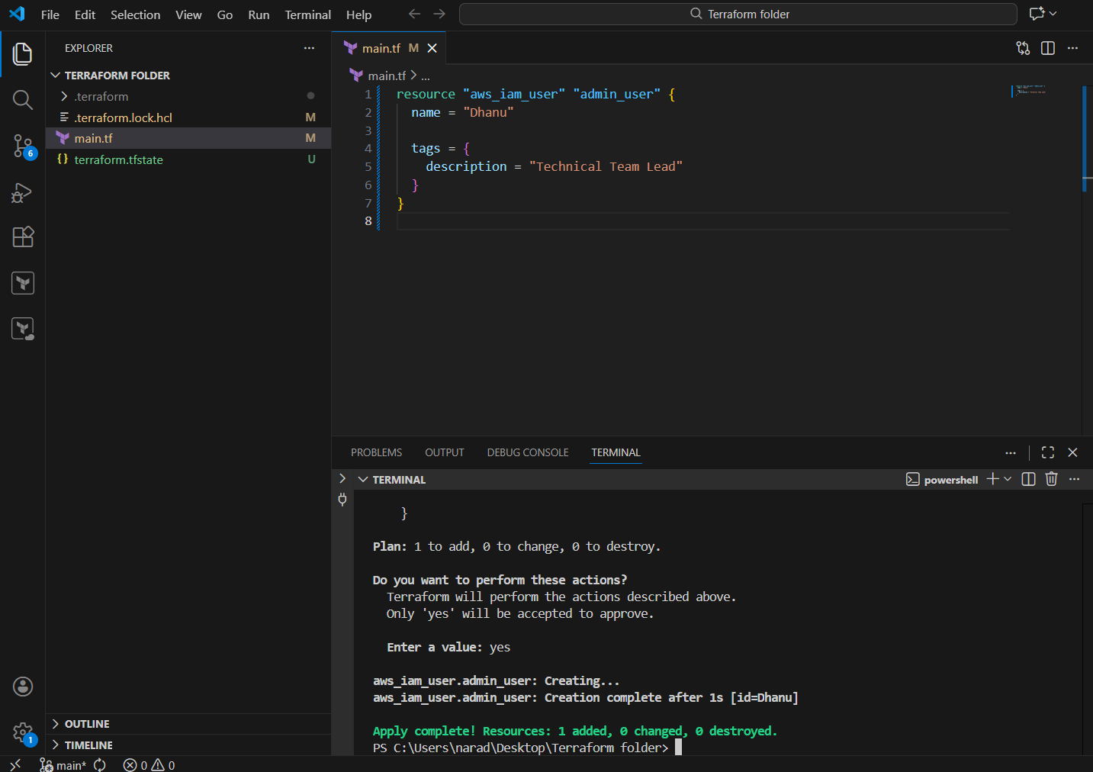
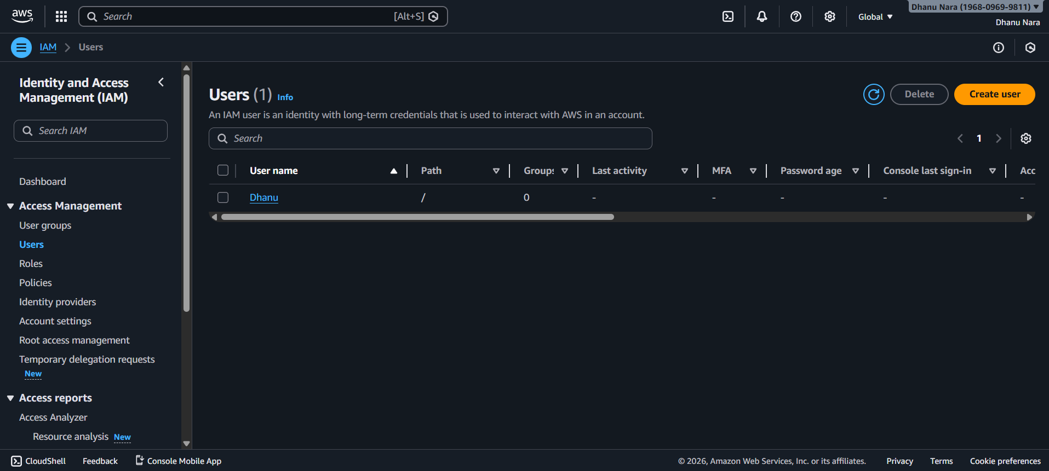

Attaching policies to the user.
# IAM USER (ONLY ONE)
resource "aws_iam_user" "admin_user" {
name = "Dhanu"

tags = {
description = "Technical Team Lead"
}
}

# IAM POLICY
resource "aws_iam_policy" "admin_user_policy" {
name = "AdminUsers"

policy = <<EOF
{
"Version": "2012-10-17",
"Statement": [
{
"Sid": "AdminAccess",
"Effect": "Allow",
"Action": "*",
"Resource": "*"
}
]
}
EOF
}

# ATTACH POLICY TO USER
resource "aws_iam_user_policy_attachment" "dhanu_admin_access" {
user = aws_iam_user.admin_user.name
policy_arn = aws_iam_policy.admin_user_policy.arn
}

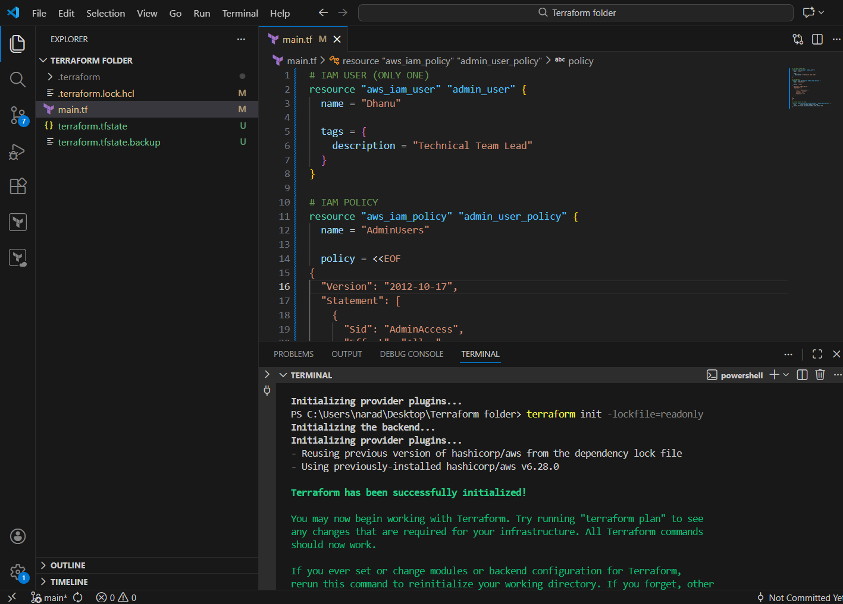
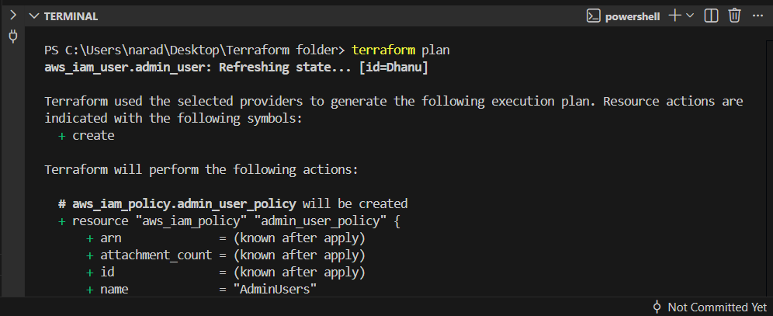
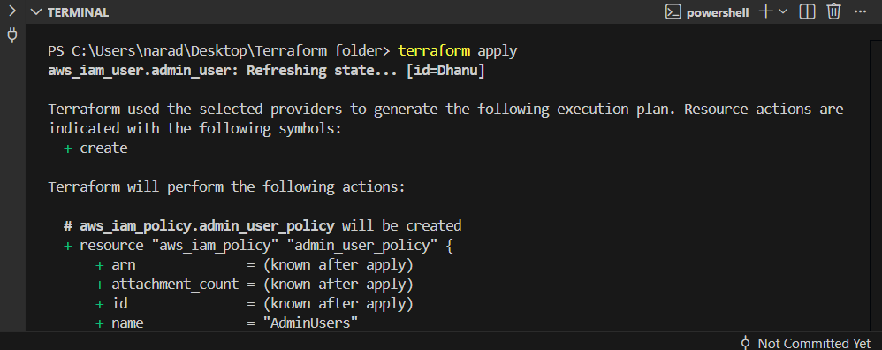
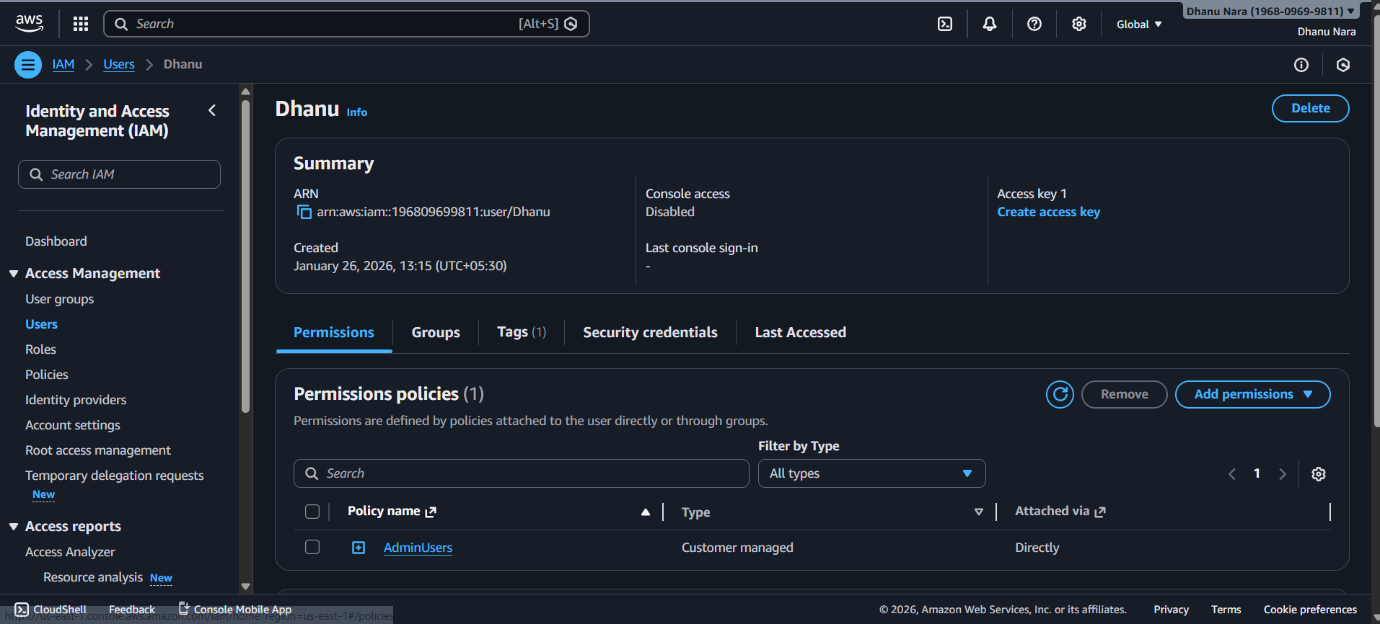

Integrate Terraform in Jenkins using the Terraform plugin.

Title
Integrating Terraform with Jenkins Using Terraform Plugin

Objective
To automate the provisioning of AWS infrastructure by integrating Terraform with Jenkins using the Terraform plugin and executing Terraform commands through Jenkins jobs.

Prerequisites
- Jenkins installed and running
- Terraform plugin installed in Jenkins
- AWS account with access keys
- GitHub repository containing Terraform files
- Git plugin installed in Jenkins

STEP 1️⃣ Install Required Jenkins Plugins
Go to:
Manage Jenkins → Plugins → Available
Install:
- Terraform
- Git
- Aws credentials

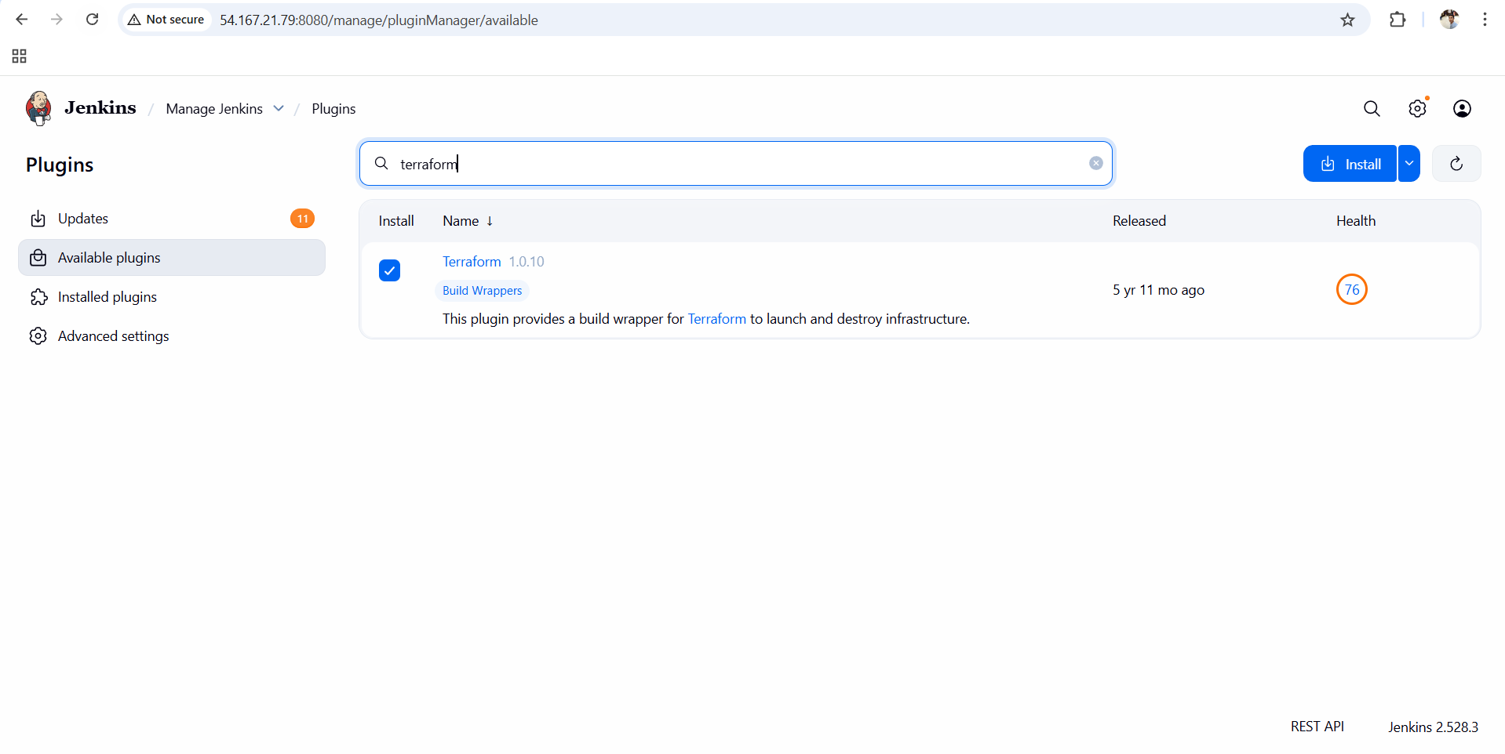

STEP 2️⃣ Configure Terraform in Jenkins (Global Tool)
Go to:
Manage Jenkins → Tools
Scroll to Terraform section:
- Click Add Terraform
- Name:
- terraform
- ✔ Check Install automatically
- Version: choose latest stable (example: 1.6.x)

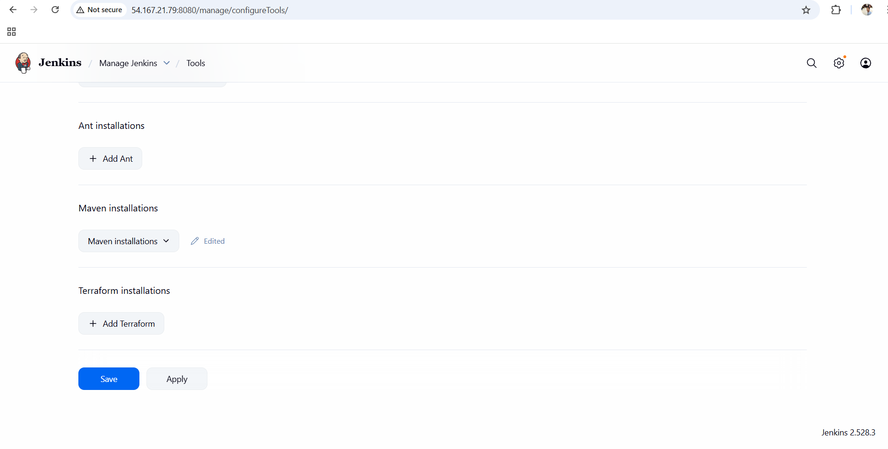
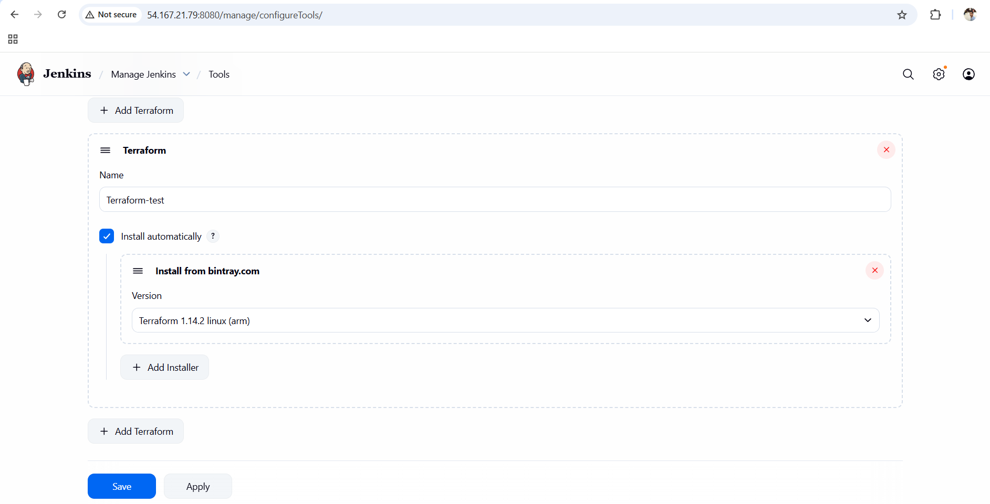

STEP 3️⃣ Add AWS Credentials in Jenkins
Go to:
Manage Jenkins → Credentials → (global) → Add Credentials

Select:
- Kind: AWS Credentials

Fill:
- ID:
- aws-creds
- Access Key ID: <your_aws_access_key>
- Secret Access Key: <your_aws_secret_key>

THESE CREDENTIALS HAS TO BE TAKE FROM AWS IAM

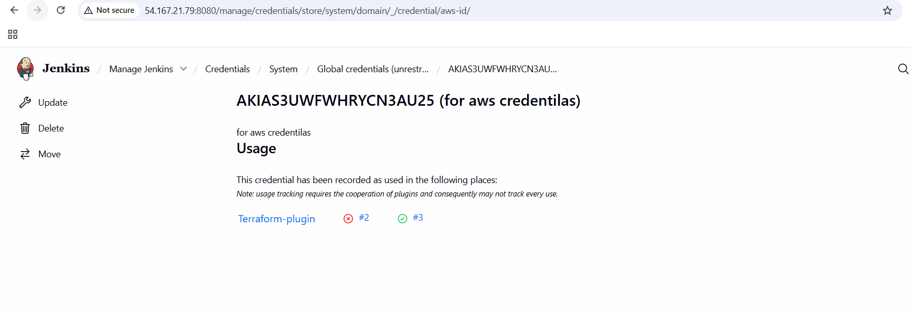
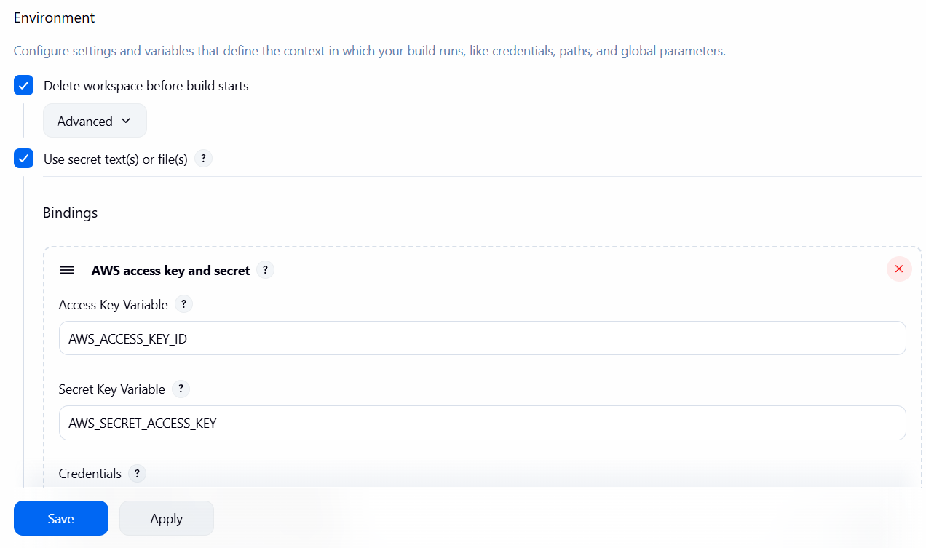

STEP 4️⃣ Create Jenkins Job
Go to Jenkins Dashboard:
New Item
- Job Name:
- terraform-job
- Select:
✅ Freestyle project
- Click OK

STEP 5️⃣ Connect GitHub Repository
Inside job configuration:

Source Code Management
- Select: Git
- Repository URL:
- https://github.com/<username>/<repo>.git
- Branch:
*/main

Add these commands in Build steps

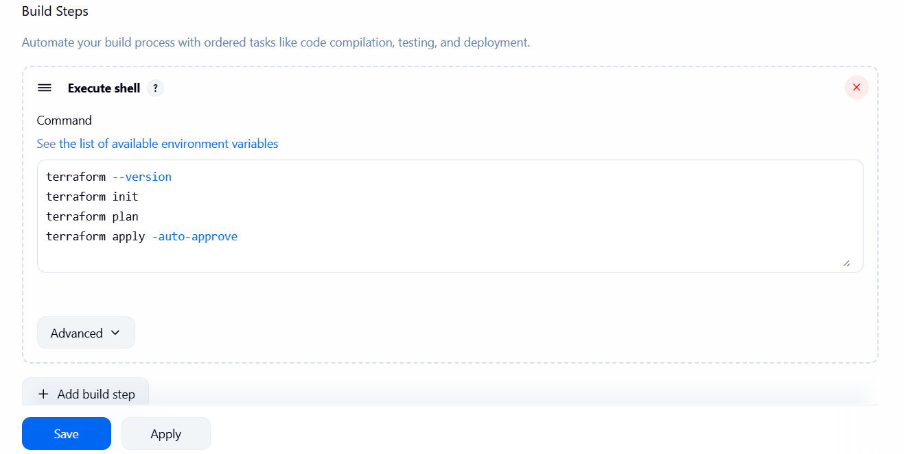

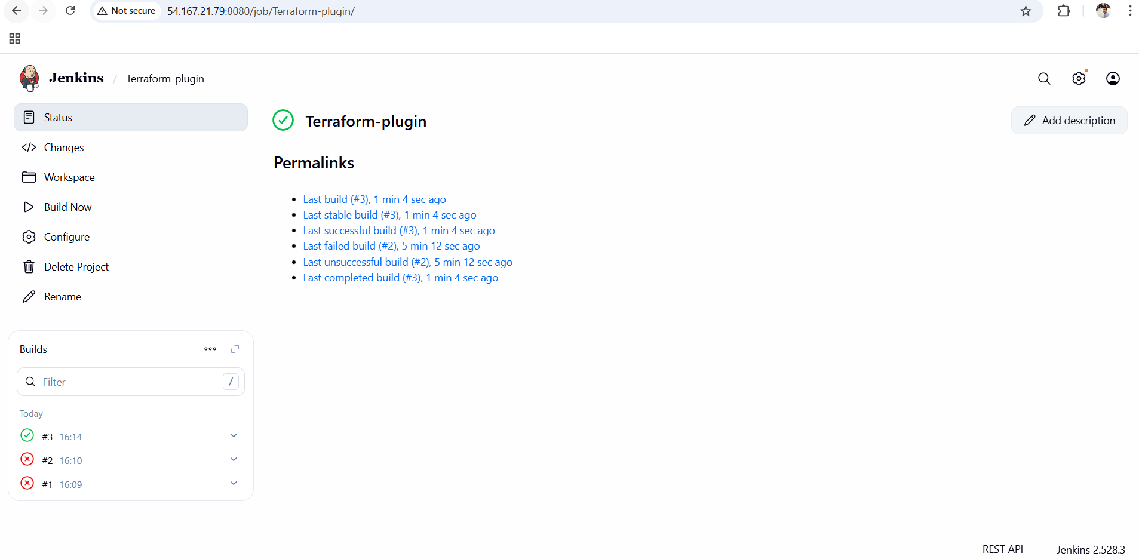

Conclusion
Terraform was successfully integrated with Jenkins using the Terraform plugin. Jenkins now automates Terraform workflows such as init, plan, and apply, enabling consistent, repeatable, and automated infrastructure provisioning through CI/CD pipelines.

Create a CI/CD pipeline for a Nodejs Application: https://github.com/betawins/Trading-UI.git

Step-by-Step Implementation

Step 1: Fork the GitHub Repository
- Open the original Node.js repository in GitHub
- Click Fork
- Fork it into your GitHub account
- Verify:
  - Repository is accessible
  - Branch is master
  - Jenkinsfile exists in the root directory
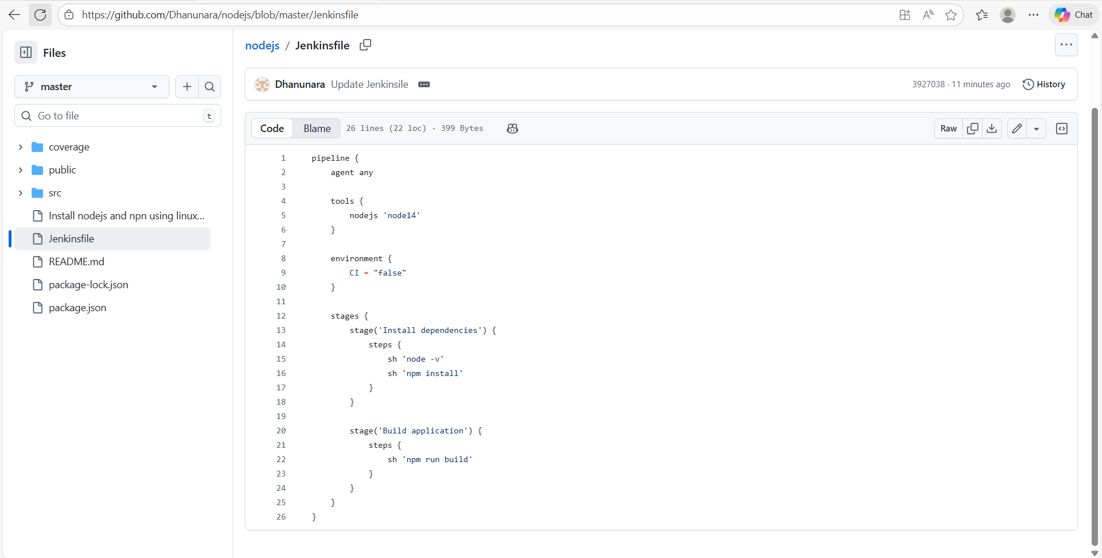

Step 2: Install Required Jenkins Plugins
- Go to Manage Jenkins → Plugins
- Install:
  - Pipeline
  - Git
  - NodeJS Plugin
- Restart Jenkins if required
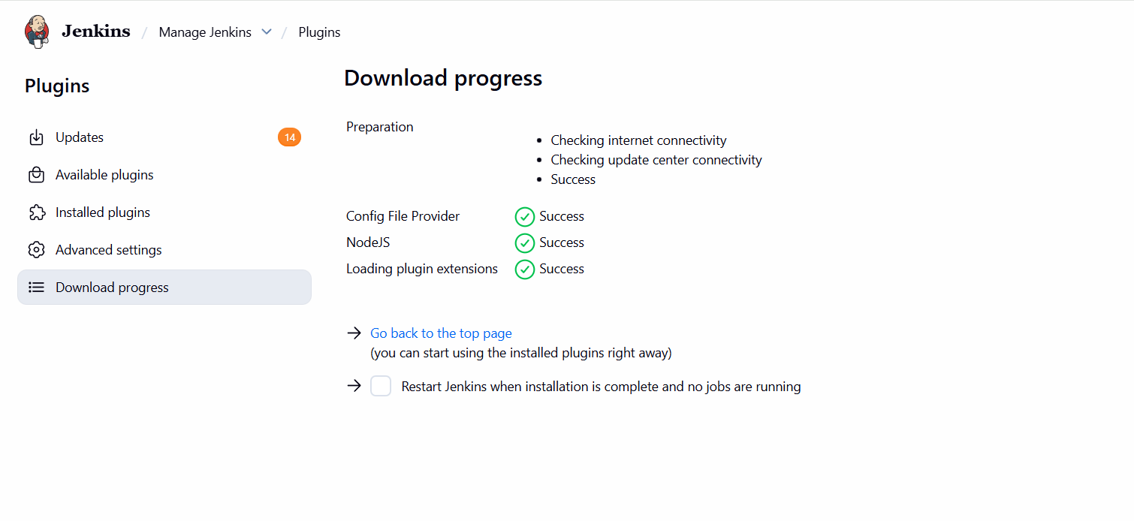

Step 3: Configure NodeJS Tool in Jenkins
- Go to Manage Jenkins → Tools
- Scroll to NodeJS
- Click Add NodeJS
- Configure:
  - Name: node14
  - Install automatically: ✔
  - Version: NodeJS 14.0.0
- Save configuration

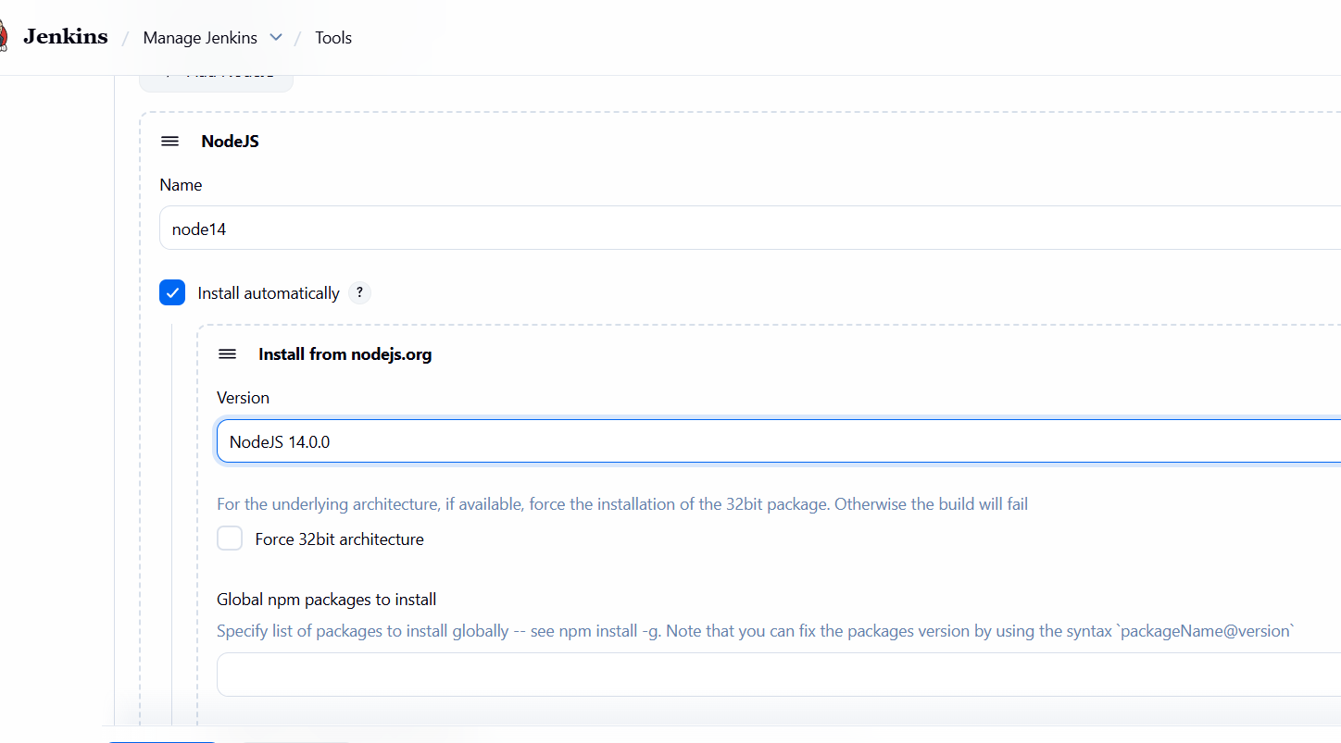

Step 4: Create Jenkins Pipeline Job
- Jenkins Dashboard → New Item
- Enter job name: NodeJs-job
- Select Pipeline
- Click OK
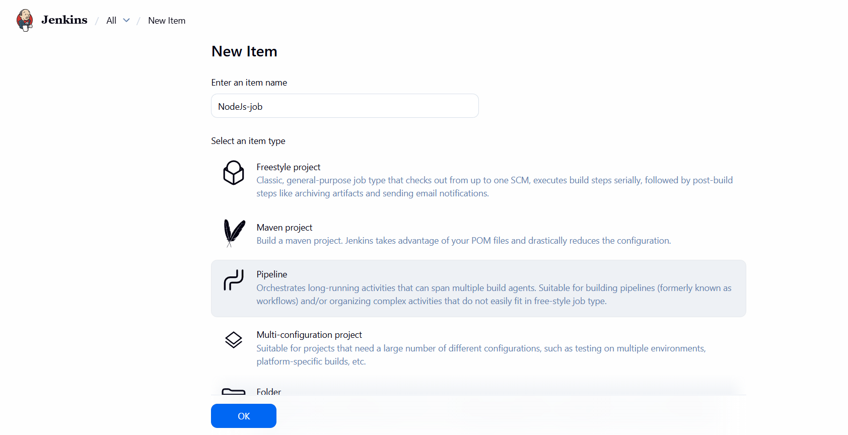

Step 5: Configure Pipeline from SCM
- Under Pipeline section:
  - Definition: Pipeline script from SCM
  - SCM: Git
  - Repository URL:
  - https://github.com/<your-username>/nodejs.git
  - Branch Specifier:
  - */master
  - Script Path:
  - Jenkinsfile
- Save the job

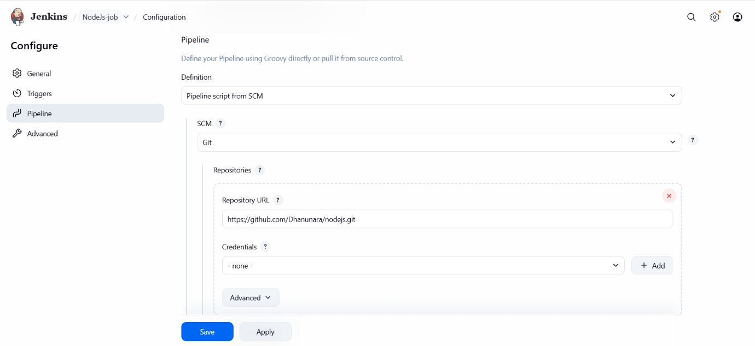

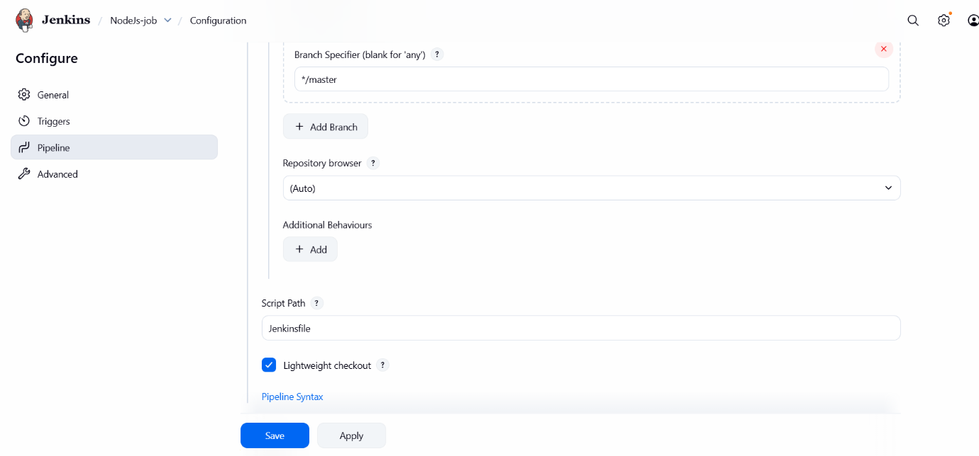
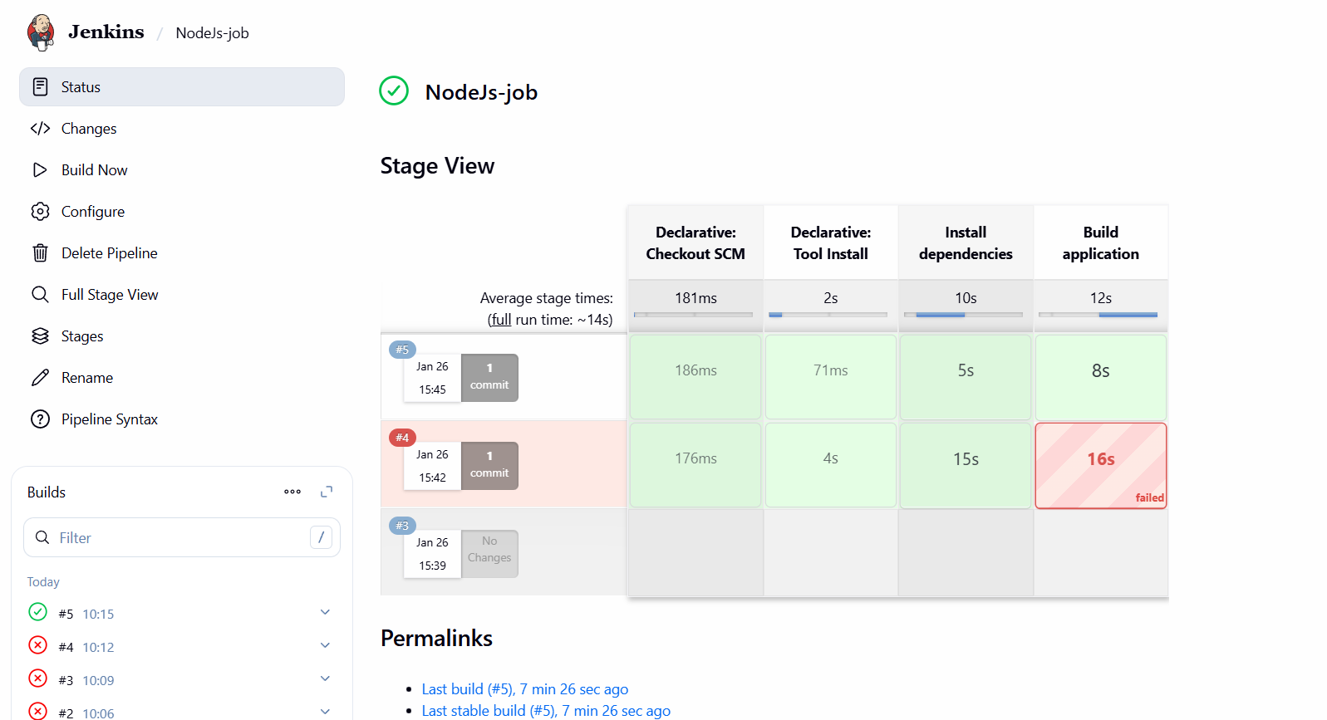

✅ Final Outcome
- Jenkins pipeline executed successfully
- Node.js application built without errors
- Proper stage-wise visualization achieved
- Legacy project compatibility handled correctly
- CI pipeline ready for real-world usage

🧾 Conclusion
This project demonstrates how to build a production-ready Jenkins CI pipeline for a legacy Node.js/React application. By configuring the correct Node.js version, handling CI-specific behavior, and using Jenkins tools effectively, we achieved a stable and repeatable build process. This approach reflects real-world DevOps practices and ensures reliability across environments.

10 Maven Commanda

1️⃣ mvn --version

🔹 What it does
Shows the Maven version, Java version, and OS details.

🔹 Why we use it
- To verify Maven is installed
- To check Java compatibility

🔹 Example
mvn --version

2️⃣ mvn clean

🔹 What it does
Deletes the target/ directory (old compiled files).

🔹 Why we use it
- Ensures a fresh build
- Removes old artifacts

🔹 Example
mvn clean

3️⃣ mvn compile

🔹 What it does
Compiles the source code (.java files).

🔹 Why we use it
- To check if code compiles
- Does NOT run tests

🔹 Example
mvn compile

4️⃣ mvn test

🔹 What it does
Runs unit test cases using JUnit/TestNG.

🔹 Why we use it
- To validate application logic
- Finds bugs early

🔹 Example
mvn test

5️⃣ mvn package

🔹 What it does
Creates a package (JAR/WAR) in target/.

🔹 Why we use it
- Generates deployable file
- Runs tests before packaging

🔹 Example
mvn package

6️⃣ mvn install

🔹 What it does
Builds the project and stores the artifact in local repository (~/.m2).

🔹 Why we use it
- Makes artifact available to other projects
- Used in CI pipelines

🔹 Example
mvn install

7️⃣ mvn deploy

🔹 What it does
Uploads the artifact to a remote repository (Nexus/Artifactory).

🔹 Why we use it
- Share artifacts across teams
- Used in production pipelines

🔹 Example
mvn deploy

8️⃣ mvn validate

🔹 What it does
Checks if the project structure and pom.xml are correct.

🔹 Why we use it
- Early validation before build
- Detects configuration issues

🔹 Example
mvn validate

9️⃣ mvn clean install

🔹 What it does
- Deletes old build
- Compiles, tests, packages, and installs

🔹 Why we use it
- Most commonly used command
- Ensures clean & complete build

🔹 Example
mvn clean install

🔟 mvn dependency:tree

🔹 What it does
Shows the dependency hierarchy of the project.

🔹 Why we use it
- Find dependency conflicts
- Debug version issues

🔹 Example
mvn dependency:tree

